EBU CLEAR PRINT GUIDELINES
Thank you for downloading the EBU clear print guidelines for producing information that is also legible for persons with reduced vision.
This document offers basic principles with good practice examples that you can easily apply in all your printed and electronic communication activities.
Making your texts accessible benefits people with sight loss as well as a far wider audience: the general public. By implementing the principles of Inclusive Design (also called Universal Design) you too can make an important contribution to a more accessible and inclusive society!

CONTENTS
ABOUT EBU 3
ABOUT SIGHT LOSS 4
1. CLEAR PRINT GUIDELINES 5
1.1 Contrast 5
1.2 Text colour 5
1.3 Font family/type 6
1.4 Font size 6
1.5 Font style 7
1.6 Font heaviness 7
1.7 Letter spacing 7
1.8 Leading 7
1.9 Alignment 8
1.10 Margins 8
1.11 Column 8
1.12 Headings 9
1.13 Page numbers 9
1.14 Table of Content 9
1.15 Tables 9
1.16 Paper finish 10
2. GRAPHICS AND ILLUSTRATIONS 11
2.1 Contrast 11
2.2 Clear and simple design 11
2.3 Size and position 11
2.4 Text over image 11
2.5 Description 12
2.6 Animation 13

ABOUT EBU
EBU is the united voice of more than 30 million persons with sight loss in geographical Europe, protecting their rights and promoting their interests.
EBU works towards a more accessible and inclusive society with equal opportunities for all, to fully participate in social, economic, civil, political and cultural life.
With its large network of organizations in 44 countries, EBU brings together a wealth of knowledge, expertise and first-hand experience in low vision and blindness and its impact on the lives of millions. EBU is active in different working areas. Initiatives involve awareness raising, lobbying and sharing of good practices, providing guidelines, creating partnerships, empowering blind and partially sighted persons and their organizations.
All EBU activities build on the UNCRPD (The United Nations Convention on the Rights of Persons with Disabilities).
Access to information, goods and services, a safe and accessible physical environment are a prerequisite for an inclusive and barrier-free society.
It begins with the way we communicate with each other: signs, ads, books, websites, brochures, product packages and so many other communication materials we absorb in everyday life.
The EBU clear print guidelines make electronic and print text more legible for individuals with vision problems and for the general public as well. Therefore, they constitute an example of the Universal Design (Inclusive Design) principles.

ABOUT SIGHT LOSS
It is estimated that there are over 30 million people with sight loss in geographical Europe. The vast majority has low vision or partial sight - two terms for the same condition.
With the growing population of elderly, the number of persons with sight loss will only increase in the coming years.
Low vision is a condition in which daily tasks and activities are found difficult to perform, despite glasses, contact lenses, surgery or medicine. Activities like, for example, watching TV, reading the mail, writing, shopping, cooking, recognizing faces, orientation and mobility, can be affected.
There are many different causes for sight loss and persons of all ages can be affected, whereby elderly and women are at higher risk.
There are many different ways and degrees of seeing. Many factors determine the impact that sight loss has in one´s daily life.
Reduced vision often makes reading difficult, for example because of a reduced amount of light entering the eye, because of blurred vision, or because of damage to the central vision with which one focuses when reading.
In general, these conditions require high contrast, bigger text, heavy (bold) lines, and specific lighting.
Different ways of seeing require different solutions. Devices and technical aids can help, but are not always available or affordable. While it is quite easy to make texts better accessible with the basic principles described in the EBU clear print guidelines.

1. CLEAR PRINT GUIDELINES

1.1 Contrast - Design texts in the highest possible contrast
Contrast is one of the most critical factors in enhancing visual functioning for those who have low vision. For digital and printed materials as well as in environmental design, the best possible contrast should be used.
Light lettering on dark background or dark text on a light background. Use low brightness for backgrounds and brighter for lettering.
Good practice examples of high-contrast colour combinations are black/dark blue on an off-white or light yellow background, and white/yellow text on black or dark blue.
Use a single colour background for a text, avoid colour effects like fading or two-tone designs.
Most people with low vision suffer from glare, and so for many a dark background with light lettering is preferred.
Below an illustration of a good contrast example of yellow font on dark blue background:
Good, high-contrast colours for text and background

An example of bad contrast: yellow font on orange background:
Do not use low-contrast colours for text and background

1.2 Text colour
Printed and electronic material is clearer when in black and white. Use coloured text for titles, headlines or highlighted information. Always in the highest possible contrasting colour with the background.
In this document, for instance, the text for headings is dark blue and bold.
See also the two illustrations below.
First, a good example: black text on white background, followed by a bad example: yellow text on white background:
Printed or digital text is clearer when in black and white.

Printed or digital text becomes invisible when in a non-contrasting colour.

1.3 Font family/type
Choose standard fonts with easily recognizable upper and lower case characters, without serifs (sans serif).
Arial, Verdana, Helvetica are good choices.
Do not use complicated or decorative fonts, serif fonts such as Times new Roman, nor handwriting type fonts.
Below an illustration of a good font type, followed by examples of fonts you should avoid:
Arial is a good choice
Avoid Times New Roman type fonts and handwriting type fonts

1.4 Font size
Keep text in a large font, preferably between 14pt - 16pt - 18pt Arial or similar. Note that, depending on the font type you choose, you may need to adapt the pt value to match the Arial 14-16-18 sizes.
Below two illustrations. First a good font size example, followed by a size you should avoid:
Arial 16 is a good font size
Arial 9 is a too small font size

1.5 Font style
Use a bold or heavy font for headings or to emphasize information. CAPITAL letters should be used only in titles and headings if needed. When quoting, use quotation marks instead of italic. As an option, you can additionally indicate between brackets, when the quote starts and ends.
Avoid Italics, underlined text or UPPER CASE letters in texts. Limit their use to an absolute minimum.

1.6 Font heaviness
Choose fonts with medium heaviness. Avoid fonts with light type with thin strokes or one with a combined thin and heavy stroke.
Use bold or heavy font when emphasizing a word or passage or for titles, subtitles and headings.

1.7 Letter spacing
Use monospaced letter type. This means that each letter is separated by exactly the same small distance from the other letters in a word, while there is more space between words. This makes reading easier for partially sighted persons.
Letters that are too close together, or too separated, as well as different (proportional) spacing, highly complicate legibility for partially sighted readers and are therefore not accessible.
Below first a good example of adequate mono letter spacing, followed by an example of inadequate letter spacing that you should not use:
Arial has mono letter spacing of an adequate small width between each letter.
Bad example:
This font type has proportional letter spacing, which complicates reading and should therefore be not be used.

1.8 Leading (the space between lines of text)
Keep it between 25 and 30 percent of the font size (usually 1.1 - 1.5) as to assist readers move their eyes more easily to the next line of text.

1.9 Alignment
Whenever possible, use left alignment. This is highly recommended as it facilitates reading and is preferred over justified text.
Justified text is not recommended, since it can leave big gaps between words that make reading very complicated for partially sighted readers.

1.10 Margins
Use wide margins as this helps when reading. Use spiral binding margin, since this is especially helpful in bound materials when making use of reading aids, such as magnifiers and CCTV.

1.11 Columns
An option is to divide text into columns, if you so choose. It can make text easier to read, as it requires less eye movement and less peripheral vision. For this to work, depends on the font size and the size and orientation of your (printed or electronic) document.
A4 or larger with Arial 14pt for example. Do not use columns in smaller brochures and leaflets.
This is a good example of text into columns on an A4 document:
EBU is the united voice of blind and partially sighted people in Europe. Founded in 1984, EBU is a non-governmental, non-profit-making European organization that protects the rights and promotes the interests of the estimated thirty million persons with sight loss in geographical Europe.
EBU works towards an accessible and inclusive society with equal opportunities to full participation of blind and partially sighted people in all aspects of social, economic, civil, political, and cultural life.
All EBU activities build on the UNCRPD (United Nations Convention on the Rights of Persons with Disabilities).

1.12 Headings
Ensure that headings are visible and easily identified.
In printed and electronic information it is a good practice when the headings are in bold font, and a bit larger than the general text, in the same colour as the text, or in a different, but high contrast colour.
The heading can be displayed on a contrasting stripe or rectangular background with contrasting bold lettering.
Here is an illustration of a good example of a heading on a contrasting rectangular background feature in dark blue with bold white lettering:
Heading 1

1.13 Page numbers
Ensure that page numbers are visible and in a consistent location. For printed and electronic information, it is a good practice when the page number is displayed in bold lettering on a contrasting stripe, circle or square background.
The illustration below shows a good example of a page number displayed in bold white lettering on a contrasting blue square background that clearly stands out from the white background of the document:
Page 11

1.14 Table of Contents
A table of contents is useful to include for quick navigation in electronic versions. Make the list of contents active, so that readers can click on an item in the content, taking them directly to that item in the text.

1.15 Tables
Ensure that the tables have visible bold borders with sufficient space between text and border.
Example:

1.16 Paper finish
In case of printed information, ensure that the paper has a matt finish. Avoid glossy finishes, as these produce uncomfortable glare for persons with low vision.
When you want to use white paper, avoid pure whites. Better is to choose off-white and other softer, matted whites.

2. GRAPHICS AND ILLUSTRATIONS
When choosing or designing graphics and illustrations, the same principles apply of contrast, colours, simple design, good size, and heaviness (bold).
A picture can say more than a thousand words, if VISIBLE!

2.1 Contrast
Use illustrations and pictures with contrasting colours. Also contrasting contours are a good option. Use heavier lines. Avoid fine, thin lines.

2.2 Clear and simple design - less is more!
Illustrations should be clear, recognisable and easy to understand. The power of good design is for readers to ´get the picture´ right away.
Avoid complicated and overcrowded images, unless these serve a specific purpose and have a adequate description going with it.

2.3 Size and position
Use a large size and whenever possible displayed directly following the related text.
Depending on the type of document, and on the type of illustration, an option could also be to display it on a separate page, dedicated to the illustration. In print version, immediately next to the concerned text, in digital version, immediately following the related text.

2.4 Text over image
Avoid text on an image, unless visibility can be guaranteed with high contrast between background and lettering. It is good practice to create a one colour, high contrast background the size of the text, or larger than the text, to place contrasting font on.
Here are two illustrations:
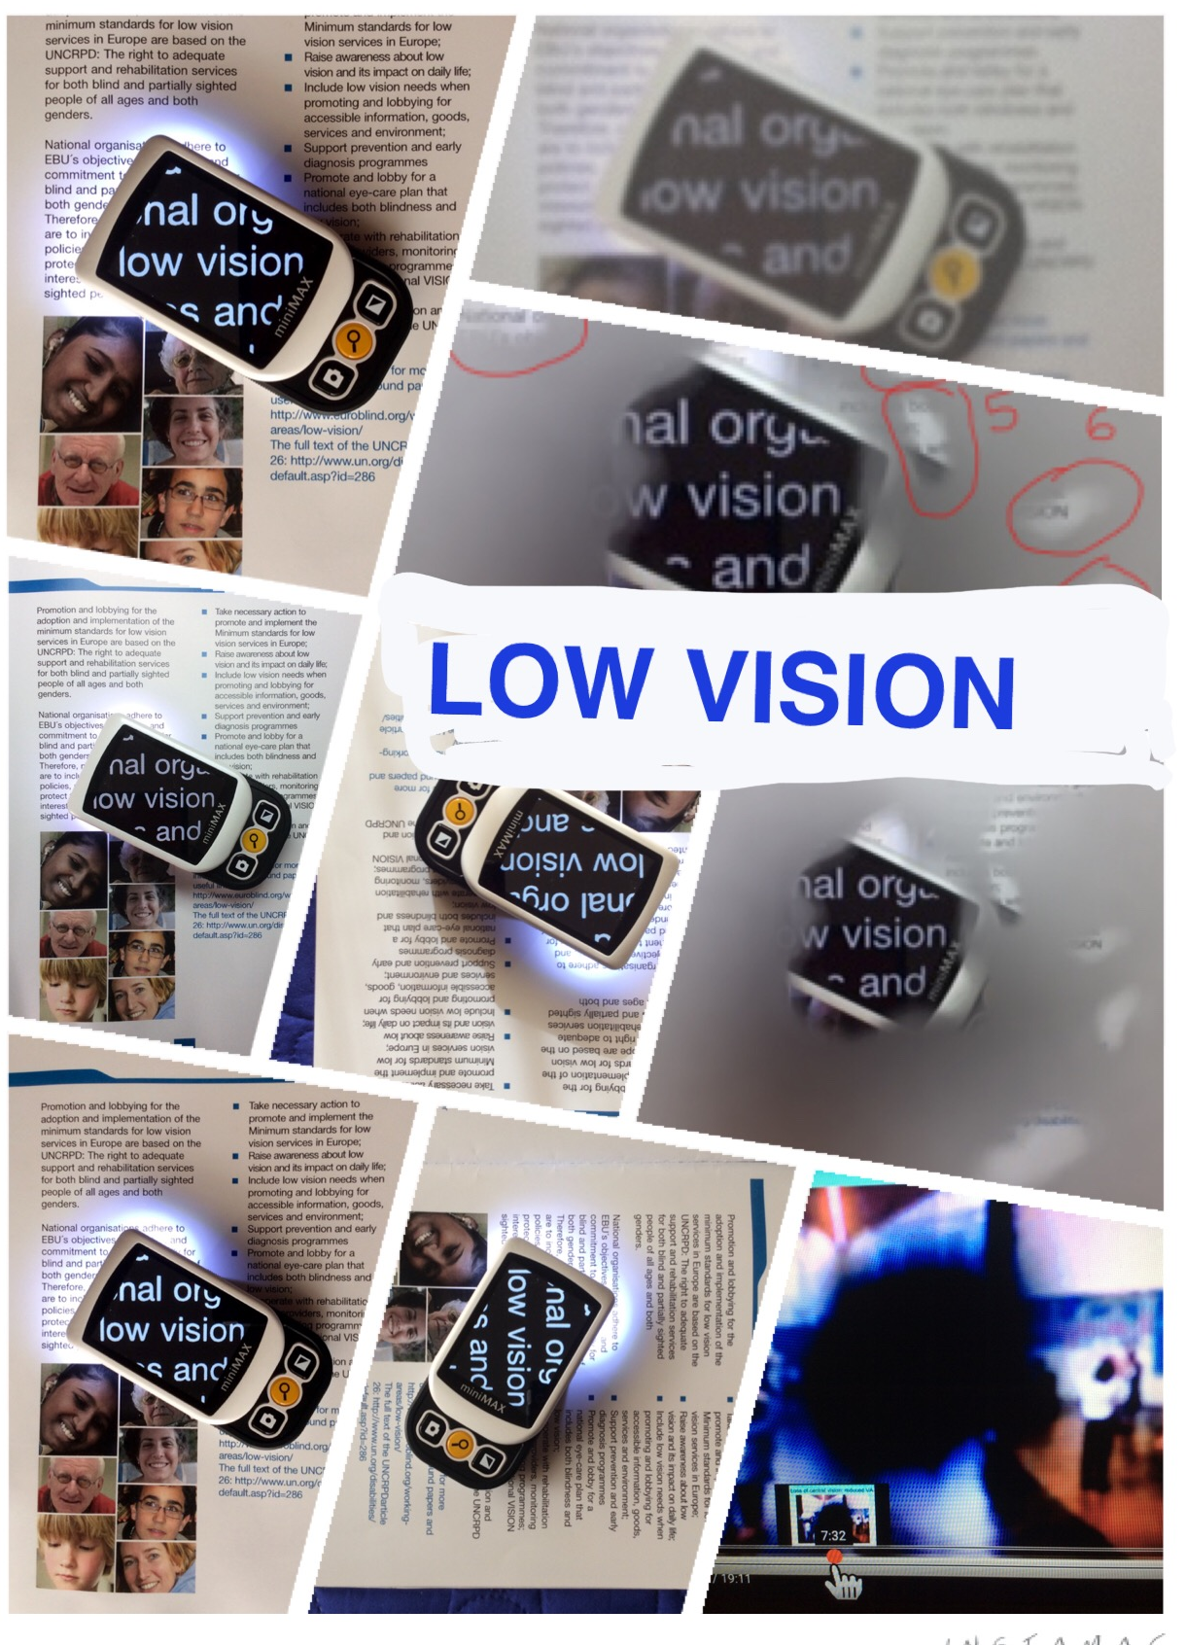
First, a good example of legible text over images: the white rectangle forms a good contrast with both the dark blue lettering and with the colour images that make up the background.
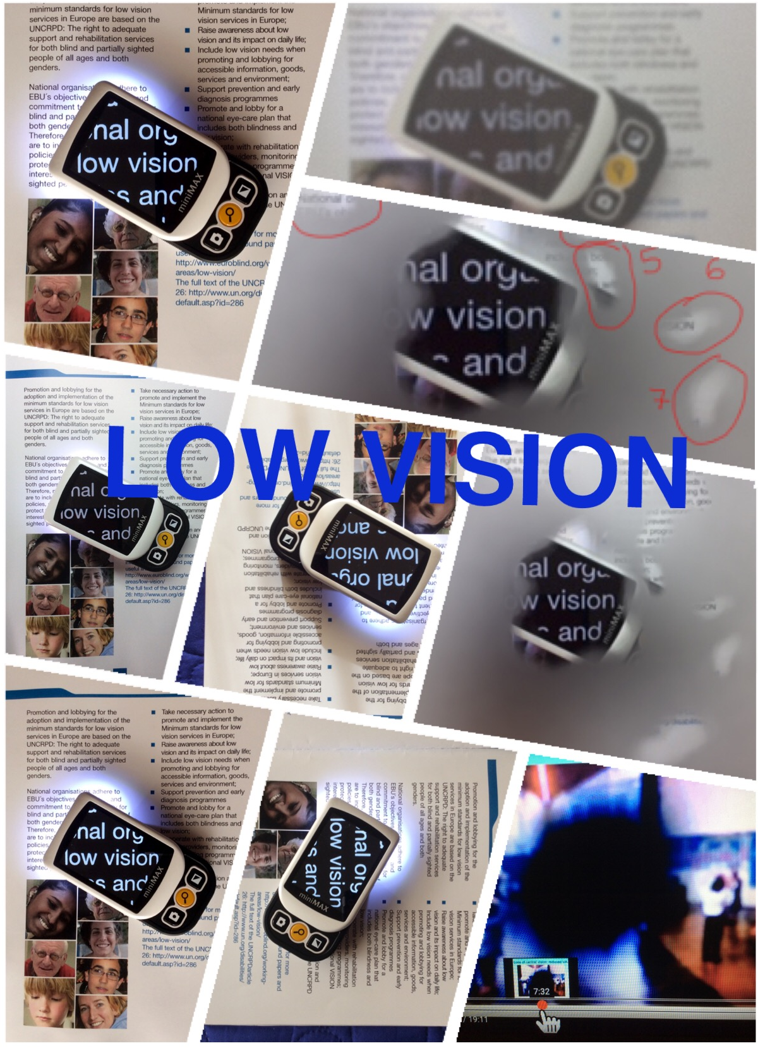
Next is a bad example: the lettering on the background of coloured images is invisible, and should therefore not be used or even considered.

2.5 Description
The essence and function of an illustration.
In printed and digital information, a description of the illustration is necessary, directly before, above, under or next to the illustration.
The detail in which it is described, depends on the function of the image.
For example, the purpose of the two pictures shown above, under point 2.4 was to show how text can be visible or invisible on a coloured background with images. What is on the images, and how many images make up the picture, is not important for the purpose of the illustration.
Note that Twitter now allows to include a description to an image before uploading it in a tweet, which is a good tool to improve accessibility and we encourage you to use this option.

2.6 Animation
In digital documents or in presentation, animations should be avoided, unless these are (audio) described.

For Further Information
Complement the EBU Clear Print Guidelines with the guidelines for making accessible PDF for blind and partially sighted persons, the W3C guidelines for making accessible websites.
For more information contact the EBU central office in Paris:
EBU - The voice of blind and partially sighted people in Europe
Website: www.euroblind.org
E-mail: ebu@euroblind.org
Telephone number: +33 1 47 05 38 20
Address:
6 Rue Gager-Gabillot
75015 Paris, France
End of EBU clear print guidelines.
Updated version, October 2016.

