Name: Zuzana FÄHREROVÁ
Gender: Female
Age: 22.
Country: Slovakia
EBU member: Slovak Blind and Partially Sighted Union
Number of words in original language: 1100

Theme: Amusing stories about Braille

Dots as the best gift?
March 29, 2017, Tuesday 1:36 a.m.
I cannot believe it, simply… that they are really such… they just pretended. And I still had doubts… oh… it will be soaked again in my “diary”. Where have I put that handkerchief… I’m doing my best but tears are running down my cheeks, drop after drop. At least the girls are already sleeping.
It was an ordinary day. Actually it meant more to me, but I no longer had expectations that my birthday would be something special, because I was often disappointed. I was disappointed that no "prince" had appeared, that I had not won a lottery, and especially because most of the people I expected to remember me forgot about me completely. Even now, despite the fact that on a trip in Italy, where we were together with my friend at the beginning of March, we talked at least three times about birthdays (and also mentioned mine), my friend did not even congratulate me, although on that day we coincidentally met face-to-face. I understand that somebody else’s birthday is not that important for everyone, but there are already smartphones, numerous applications or conventional calendars where one can enter various events. When someone is important to me, I make sure to not miss his or her birthday, don’t I? So why does everyone always forget about mine? If a person does not have their birthday on a social network, no one will write to him or her. When everyone sees it, the birthday person receives congratulations even from people they may not even have met. Even my godmother is different than she used to be. She only sent one message on Facebook, and just to my timeline and she thinks that’s enough. At least my father pleasantly surprised me to congratulate me with a bouquet of roses. My mother wrote only a message on paper, saying "Happy birthday to you" because we did not even meet on that day. What’s more, we even had a big fight when baking in the evening. I wanted to prepare a snack for those with whom I go dancing. Usually, when someone celebrates, they prepare some snacks for others. I did so in an attempt to "show off" as well as to better fit into the group. It eventually did not end up as I fancied it at all. I forgot that celebrations are held at the end of the training. I laid out salty and sweet cakes on the table before the training. Everyone considered it a "common" snack, which was eaten up by the end of the training. Only a few scraps were left on the table in empty boxes and a bouquet, which the teacher had brought - she had received it on the teacher’s day. Of course, everyone was asking, who brought those beautiful flowers and whether that person was celebrating something. Few people noticed empty boxes next to the bouquet. As for my sister, I wanted to borrow earrings from her, so I looked in her jewelry box and "discovered" her latest set of earrings. I quite liked them, and when I wanted to ask her about borrowing them, she began to behave totally strangely. Oh, I see, I probably found my birthday present. So it was a "wonderful birthday".
Tired from the practice and totally collapsed, longing just for my bed and sleep so that I would wake up on March 29, I returned to the dormitory. My roommates usually go to bed sooner, so I was sure I would not meet them that day. As I opened the door, astonishingly I found that they were still up. They even absolutely surprised me with their request that I should stay at the door and not approach my desk. I did not quite understand what was going on, but I was looking forward to the next surprise of my "big day". I had no choice, so I had to obey. One roommate ran to the table and began to film me as I was approaching it. There was a page from newspapers with a message: “Happy birthday from GYOB” (this is the abbreviation of our volunteer group, with which we carry out from time to time a charity activity, i.e. we visit children’s homes). I laughed, but I still did not know why they gave me the newspapers. And then I found out that the newspapers hid something else. I lifted them up and there was a collage. Everyone from the group took a picture of themselves with a piece of paper with dots in their hand. The photos were then carefully put in order next to each other. The collage itself made me so happy that I forgot all the things that had happened to me during the day. After all, it must have been hard work to think it up and put it together so creatively that when I count up the dots, the result is... Wait, it does not work somehow. Well, it’s not 22 but 51, why? And I suddenly realized it. It was Braille. It was all clear to me. I was holding a collage in A4 size landscape, which consisted of three lines. In the first line the word put together was “h-a-p-p-y”, in the second one there was a photo of a heart made of green buttons, followed by as if the letters “b-i-r-t-h”, and in the third line there were letters as if “d-a-y” and at the end of the line there was an exclamation mark made of a carrot and apple. Everyone depicted the “dots” in their own style. Somebody had flowers instead of the dots, another one had hearts, somebody else created faces, another one picked up a cube and covered on number six a dot that did not belong there, while future engineers carefully made sure that the distance between the dots was accurately calculated and that all the dots were the same size. On the whole, the photo touched me a lot, but after finding out that they had put together “Happy Birthday!” from Braille, it was too much. I did not even try to control my feelings, I simply burst out crying because of joy on the one hand, and on the other because I assumed they had forgotten about me. Finally, I learned that the girl we met before lunch was the coordinator of this gift, and that the roommate was given the task of filming my response to the surprise. So I’m important to them, and they seem to like me. The icing on the cake was made of cloth - a dotted bag from my roommate.
The dots might not mean anything for some people, but they gave me indescribable joy for a long time. I wish every one of us had such friends! By the way, this is also a reason why it is worthwhile studying the special pedagogy of the visually impaired ;).
I cannot believe it, simply because they are really so ATTENTIVE, and that they DID NOT FORGET about me and that they were just pretending, and everything thought up so PERFECTLY. And I had doubts about whether I really had FRIENDS …. oh… it will be soaked again in my “diary”. Where have I put that handkerchief… I’m doing my best but tears are running down my cheeks, drop after drop. At least, the girls are already sleeping.
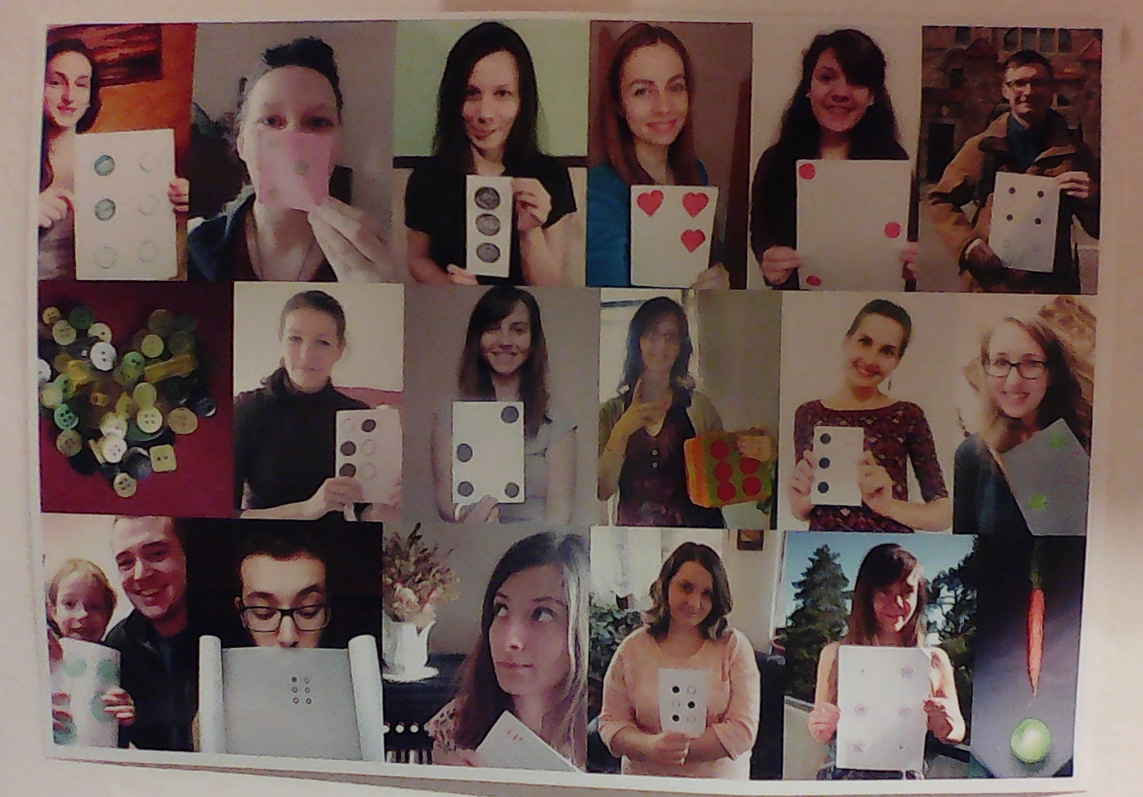

Figure No. 1. Collage made of Braille from GYOB group: “Happy Birthday!”

