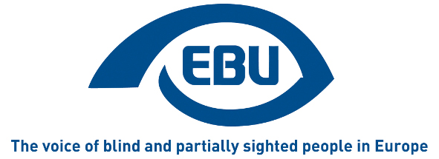

European Blind Union
Press release
Paris, 03/07/2013

HISTORIC WIPO TREATY

The end of the book famine!
History was made in Marrakesh on the 27th of June with the UN World Intellectual Property Organization (WIPO) concluding a Treaty on copyright for the visual impaired and print disabled. This was the first intellectual property treaty benefitting the public interest rather than the interest of rights holders and closed nearly five years of hard negotiations by the WBU with the active support of the EBU team and in collaboration with other NGOs. Currently, copyright law is a national jurisdiction which has the effect of preventing blind organizations form sharing books with neighbouring countries, thus causing considerable unnecessary duplication of production of books in accessible formats.

What does this mean for the visually impaired and other print disabled people? Currently only 5% of all published books in the developed countries and less than 1% in the developing countries are ever produced in the accessible formats - such as braille, large print and audio – that VI and print disabled need. At the centre of this treaty is an article giving permission for VI organisations and libraries to share their collections of accessible titles with other same-language communities around the world. Examples of this include Spain and Argentina being able to share their combined collections of over 150.000 titles right across Latin America as soon as the government of each recipient country ratifies and implements the treaty. Similarly, French language collections, Arabic collections, Chinese collections, etc., can be shared around the world to diaspora communities who cannot legally borrow or buy an accessible title from their homeland as of now.
WBU immediate past President, Maryanne Diamond, Head of the WBU Delegation at the Marrakech Treaty Talks, said “We have worked hard for this day for a very long time. We are extremely pleased that member states have reached agreement on a very good treaty which will take another step forward in the inclusion of persons who are blind in society. Adopting the treaty on the 27 June, is especially appropriate, the birth day of Helen Keller. She would have been proud to see another example of human rights prevail”.

About EBU

EBU is a non-governmental, non-profit making European organisation founded in 1984. It is one of the six regional bodies of the World Blind Union. It protects and promotes the interests of blind and partially sighted people in Europe. It currently operates within a network of national organisations of the visually impaired in 45 European countries.

EBU
6 rue Gager-Gabillot
75015 PARIS (France)
Tel: +33 1 47 05 38 20
Fax: +33 1 47 05 38 21
Email: ebu@euroblind.org
www.euroblind.org

