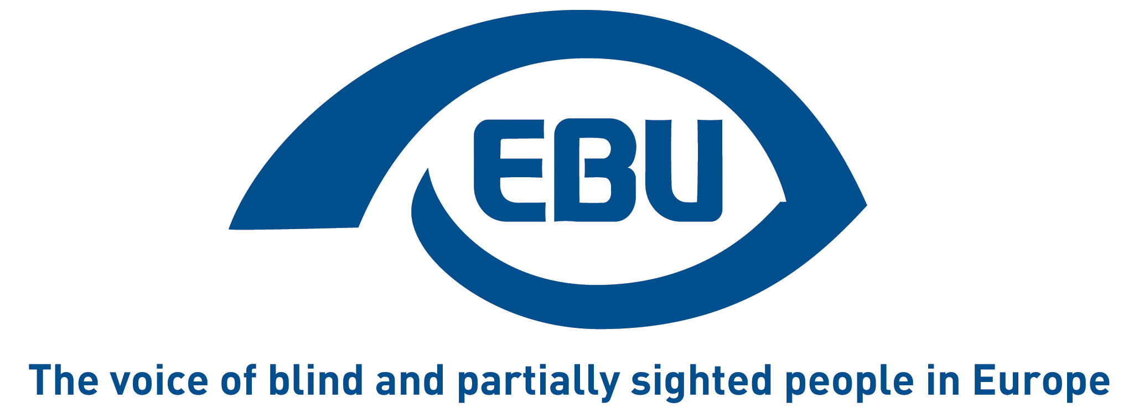

European Blind Union response to the European Commission’s public consultation on a sustainable EU food system

EBU Position Paper | July 2022

Aim of the consultation

The European Commission indicates: “The aim of this public consultation is to gather opinions and evidence from all relevant stakeholders (citizens, economic operators of all sizes, including SMEs, and organisations representing them, consumer organisations, social partners, NGOs, public authorities at all governance levels, public purchasers, academia and research institutions, as well as any other interested stakeholder) on the key issues the initiative aims to address. This consultation takes a high-level approach, focusing on overarching issues related to food system sustainability, so it is therefore aimed to attract a broad range of responses, from all stakeholder categories previously mentioned. The questionnaire is accessible in all official EU languages.”

And the Commission recalls that “the Farm to Fork Strategy announced an initiative for a horizontal framework law, to accelerate and facilitate the transition to sustainability and ensure that foods placed on the EU market increasingly become sustainable. Such an EU level intervention aims to establish new foundations for future food policies by introducing sustainability objectives and principles based on an integrated food system approach.”

General remarks
A broad definition of sustainability, that includes social inclusion
It is a good thing that the definition of ‘sustainable food system’ in this initiative includes social inclusiveness. We infer from this that sustainable labelling should therefore be understood as labelling that considers the needs of consumers with a visual impairment.
But disappointingly, there is no mention of disability or people with disabilities, nor of social inclusion more generally, in the consultation’s questionnaire.
Accessibility is mentioned twice in the consultation’s questionnaire:
- About “accessibility to sustainable processes” as a factor preventing food system actors from making sustainable choices in the production/processing/distribution/consumption of food products; and
- About “accessibility of sustainable food” as an aspect not to be harmed by the activity of a food system actor.
From the way these questions are formulated, accessibility does not appear to be addressed as a matter, for visually impaired people, to be able to make autonomous informed choices about food products as consumers.
In the past, EBU has successfully campaigned for EU legislation requiring that there be Braille labelling on pharmaceutical products. This was a real breakthrough for blind users. Accessible labelling of food products, which concerns everyday life, deserves the same attention from the EU law makers, at least focusing as a first intermediary step on largely used food products.
Braille labelling on food packaging should become more than just a spontaneous good practice of some actors of the food supply chain. The possibilities opened by new ICT should also be considered, such as, for example, the possibility to identify a product through a smartphone or a specific device.

Response to the questionnaire
Since the consultation is in the form of a questionnaire, to submit our feedback above, we have used the following most relevant question (5) allowing a reply in free text format: “In your direct experience, what are the most important obstacles in the transition to more sustainable practices?”.
In reply to the question “How important would you consider that the activity of a food system actor (to be considered as covering their internal operations/processes and/or products, within their businesses and under their control) should not significantly harm the following aspects?”, we selected the following two items:
- Accessibility of sustainable food, and
- Other – specifying this: “Labelling of food products that is accessible for visually impaired consumers – see our reply to question 5”
And in reply to the question “On which of the below aspects of sustainability, should consumers receive information to empower them to make sustainable food choices?”, we would put “Other” at the top and specified as follows: “Labelling of food products that is accessible for visually impaired consumers – see reply to question 5. Note: EBU has no opinion on the order of importance of the subsequent aspects, we just left them as they were.”
Lastly, in reply to the question “To what extent do the following factors prevent food system actors from making sustainable choices in the production/processing/distribution/consumption of food products?”, we selected “Insufficient availability of/accessibility to sustainable processes/products/services”.

About EBU
The European Blind Union (EBU) – Interest Representative Register number 42378755934-87 – is a non-governmental, non-profit making European organisation founded in 1984. It is one of the six regional bodies of the World Blind Union, and it promotes the interests of blind and partially sighted people in Europe. It currently operates within a network of 41 national members including organisations from 25 European Union member states, candidate countries and other countries in geographical Europe.

European Blind Union
6 rue Gager Gabillot - 75015 Paris
+33 1 88 61 06 60 | ebu@euroblind.org | www.euroblind.org

Contact: Antoine Fobe, Head of Advocacy & Campaigning
ebucampaigning@euroblind.org | +33 1 88 61 06 64

